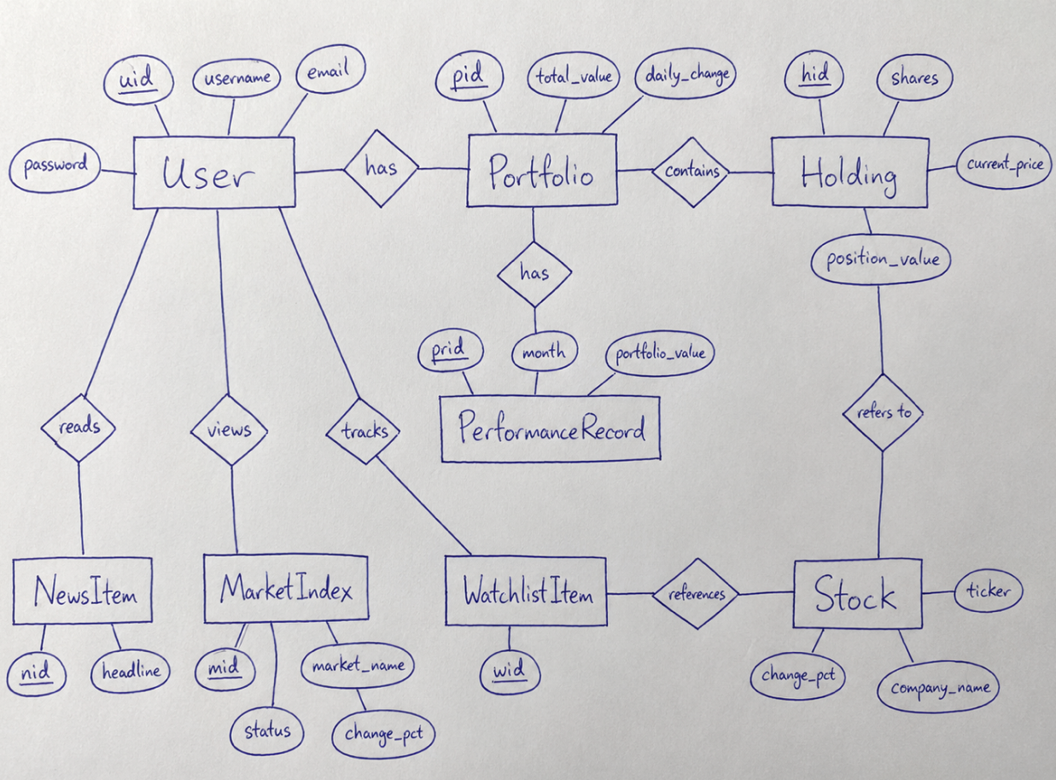
The E/R diagram models the main data structure behind the Profitly application. It shows the most important entities in the system, their attributes, and how they are related to each other.
The User entity stores information about each user, including uid, username, email, and password. The user is the central actor in the system, because the user logs in, owns a portfolio, tracks stocks, reads news, and views market information.
The Portfolio entity represents the user’s investment portfolio. Each user has a portfolio, and the portfolio stores information such as the total portfolio value and the daily change. This is the data shown on the main dashboard, where the user can see the value of their investments.
The Holding entity represents the stocks or assets that are currently owned in the portfolio. A portfolio can contain several holdings. Each holding stores information such as the number of shares, the current price, and the total position value.
The Stock entity stores general information about a stock, such as the ticker symbol, company name, and percentage change. Each holding refers to a stock, because a holding is based on a specific stock that the user owns.
The PerformanceRecord entity stores historical portfolio values. A portfolio can have several performance records, for example one for each month. This data is used to show the portfolio performance graph in the application.
The WatchlistItem entity represents stocks that the user wants to follow but does not necessarily own. A user can track watchlist items, and each watchlist item references a stock.
The NewsItem entity represents market news shown in the application. A user can read news items, such as headlines about companies or the stock market.
The MarketIndex entity stores information about the overall market status, such as the market name, whether the market is open or closed, and the percentage change for indexes like the S&P 500 or NASDAQ.
Overall, the E/R diagram explains how user data, portfolio data, stock data, market information, watchlists, news, and performance history are connected in the Profitly system.

